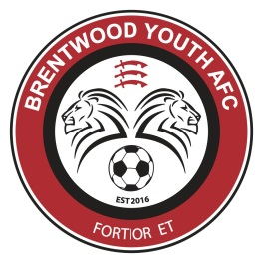 | Brentwood Youth AFC  PLAYER REGISTRATION FORM 2017/2018
Player’s Name |  |  |  |  | Date of Birth
Player’s Address |  |  |  |  | School Year
 |  |  |  |  | Post Code
 | Name | Mobile |  | Other Phone | Email Address
Primary Contact
Secondary Contact
Sibling Players Names | 1. |  | 2. |  |  | 3. |  | 4.
Medical Conditions
Player’s School
Other Football Clubs
Additional Info

I give consent for the above to participate in all activities for Brentwood Youth AFC. I understand that payment of the annual fee entitles the player and their immediate family to become members of Brentwood Youth AFC (The Club) and are therefore bound by the Club’s rules and codes of conduct which are available to read on The Club’s website. In case of an emergency, I grant permission for any qualified Club official to act in the best interests of the player. I give consent for the player to participate in all activities organised by Brentwood Youth AFC and/or the Leagues competitions that The Club is a member of. I understand that The Club cannot be held responsible for the safety and welfare of any child that leaves an organised session without permission.
Signed (Parent/Guardian)……………………………………………………………………………….………… Date ………………..…………….………

For Club Use Only | Amount Paid | Method

